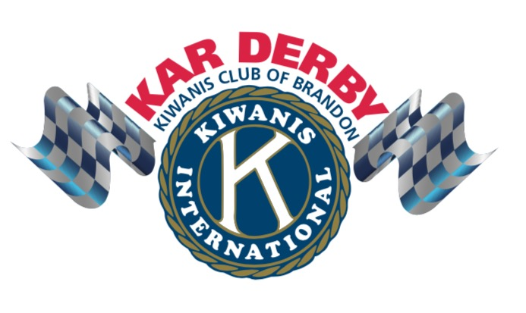

www.karderby.ca

WHEN:

The Kiwanis Club of Brandon Kar Derby will be held on Saturday, June 13th, 2026 (alternate date in the event of rain is Sunday, June 14th, 2026) commencing at 10:00 a.m. at Rideau Street, north of the park. All drivers must be at the site between 08:00 and 08:30 for inspection, registration, photos, and judging prior to trial run at 9:00. Official Races start at 10:00 am.

RULES AND REGULATIONS:

The Rules are written to give each driver a safe and equal opportunity to win. They are not meant to restrict the drivers and builders’ creative imaginations. By entering the Derby a driver pledges to follow the Derby rules, which must be read carefully and applied exactly as stated. Drivers must read the rules carefully and understand them – any questions should be put to the Derby Committee officials. The purpose of the Derby is for the drivers and sponsors to match their skills as Kar builders, against the skills and abilities of the other drivers. The Derby promotes craftsmanship and sportsmanship through honest competition. We, the Kiwanis Club of Brandon hope this is a fun day for all who participate.

- AGE: The Derby is open to girls and boys between the ages of 8 and 14 as at
December 31st, 2026 .

- ELIGIBILITY: Any Kar Kit purchased from the Kiwanis Club of Brandon is eligible for participation. A driver may enter only ONE Kar in the race. However, TWO drivers may enter the same Kar, provided they are entered in different age groups, which are 8+9yrs, 10+11yrs, 12-14yrs. A substitute driver other than the person registered is only permitted with the permission of the Derby Committee and provided the substitute driver meets the age requirements of the original driver.

- COST: Registration for one driver is $125.00 for the race. A new Kar kit costs $250.00, which includes registration for one driver. Entry Fees are only refundable up until May 24th, 2026, and are only valid for the 2026 race. There may be a few pre-built cars available for $250 that need some tlc as well, which also include registration for one driver.

4. DISQUALIFICATION: The Derby Committee will disqualify any Kar or driver that may endanger the driver, other drivers, race officials and spectators. The Committee will disqualify any Kar not built in accordance with the rules. A driver may be disqualified for poor sportsmanship and for interfering with the other drivers. Poor sportsmanship is meant to include, but is not limited to, any attempt to gain unfair advantage under the rules, such as intentional interference with the Kar and driver. A driver will be disqualified if he/she does not wear a safety helmet. A Kar will be disqualified if it is not equipped with braking system (and foot rests if feet are outside the body of the Kar). A long sleeved shirt and a seat belt is not mandatory. A Kar will be disqualified if wheels/axles are modified with bearings/bushings.

5. CONSTRUCTION: All work required in the fabrication must be based on the basic instructions supplied with each kit sold by the Kiwanis Club of Brandon (straight rear axles will be allowed). NO BEARINGS/BUSHINGS MAY BE USED ON ANY AXLE. Kars purchased in built form from the Kiwanis Club of Brandon will be constructed to meet the rules. We recommend that the chassis/floorboard be made out of 3/4” PLYWOOD – NO particleboard can be used. The cost of materials, including plywood, paint and decals are the responsibility of the purchaser. The colour of the Kar is at the purchaser’s discretion and the sponsor’s name may appear on the Kar in any form. As part of the prerace inspection, we will be checking for ballast weights, which are NOT allowed. We do not believe a heavy Kar has any advantage and heavy Kars make the job of the lifters that much more difficult.

NOTE: The length of the Kar from nose to rear axle cannot exceed 58” (1473 mm). Wheels, steering and brake hardware supplied cannot be modified. Footrests must be installed if the feet are outside the body of the Kar. There must not be any protruding objects, such as windshield mirrors or spoilers etc. on the front to the Kar. Cockpits must be open at the top – the inside edge may be covered or padded for safety. Fabric, wood, leather, paper, fiber, fiberglass, fiberboard, particle board, paper mache, plywood, linoleum, wire or cardboard may be used as body coverings.

- BRAKES: All Kars must be equipped with the brake assembly supplied with the Kar Kit.

- STEERING: The utmost care must be taken in installing the steering linkage to ensure easy, positive control and safe operation. The linkage supplied in the kit provides a very responsible steering system rotating about a point, thus minimizing the amount of energy lost to friction. Every Kar must be equipped with a full or partial steering wheel that must be not less than 10” (254 mm) in diameter and must be firmly attached to the steering shaft. Only the steering system supplied with the kit is to be used. Make sure there are no sharp projections on the steering wheel in the event of a collision

- WHEELS: The Kar must be equipped with the wheels from the kit, substitution is NOT allowed. Spare wheels can be purchased for $10 each from the Kiwanis Club of Brandon, before or during the race. Remember, no bearings/bushings may be used on any axle.

RACE PROCEDURES:

- All Kars must first pass inspection or safety and in accordance with the rules and regulations, before the Kar is allowed to race.

- After inspection, no driver shall change or modify any part of the Kar without the prior approval of the Derby Inspection Committee.

- All repairs must be made only by the driver, his/her team members and/or his/her pit crew, or qualified repairperson.

- Should a Kar be damaged after inspection, repairs must be approved by the Derby Inspection Committee.

- Kars will race in pairs as determined by the race officials from the official draw.

- Kars must start on the starting ramp, from a standstill position without assistance. When they are released from the starting gate by the Official Starter, they are propelled down the hill by the force of gravity only.

- The Kar whose nose first crossed the finish line at the bottom of the hill as determined by the finish judges is deemed to be the winner of the heat.

AWARDS:
- An Annual Trophy is awarded to the winners and runners up in each age class and may be kept for a period not exceeding one year and must be surrendered on request of the Kiwanis Club of Brandon.

- Medals are awarded to Race Winners and Runners Up in the three age classifications: i.e. 8-9, 10-11 and 12, 13 to 14.

- Keeper trophies for Best Design, Most Original and Best Decorated will also be awarded to the sponsor. Winners will be determined by the appointed judges who will judge all entries before the races commence.

- All children receive medals for participating, and will be given a printed photo of them with their car at the end of the day. Photos will be available shortly after lunch for on-site pickup at the race

INFORMATION:

If you have any questions, problems, or require parts, assistance or advice, please contact:

Darren Wright at 204-729-7670 or darrenwright72@hotmail.com
Brian Manns at 204-573-1102 or mannsbrly@gmail.com

The Kiwanis Kar Derby Committee has a list of volunteer drivers should you have a Kar but no driver of appropriate age. Please do not leave your Kar and/or helmet unattended. The Kiwanis Club of Brandon cannot be held responsible for any loss or damage to your Kar or helmet.

PLEASE NOTE THAT YOU SHOULD NOT PRACTICE ON RIDEAU STREET ON THE DAYS BEFORE THE EVENT. THERE ARE TWO GOOD REASONS FOR THIS. WE RELY ON THE GOODWILL OF THE RESIDENTS OF RIDEAU STREET WHO KINDLY ALLOW US TO CLOSE THE STREET ON RACE DAY. IF YOU ATTEMPT TO USE THE STREET BEFORE RACE DAY, THERE IS THE POSSIBILITY OF AN ACCIDENT, EITHER TO THE DRIVER OR TO THE RESIDENTS’ CARS. ON RACE DAY, WE HAVE QUALIFIED FIRST AID PERSONNEL ON SITE. THERE IS NO IMMEDIATE HELP ON THE DAYS BEFORE THE RACES. ALSO NOTE THAT A DRIVER HAS NO INSURANCE COVERAGE FROM KIWANIS UNTIL RACE DAY ITSELF AND ANY DAMAGE TO A PARKED CAR WILL RENDER THE DRIVER OF THE RACER LIABLE.

HAVE A GOOD TIME – DRIVE TO WIN AND DRIVE SAFELY!

